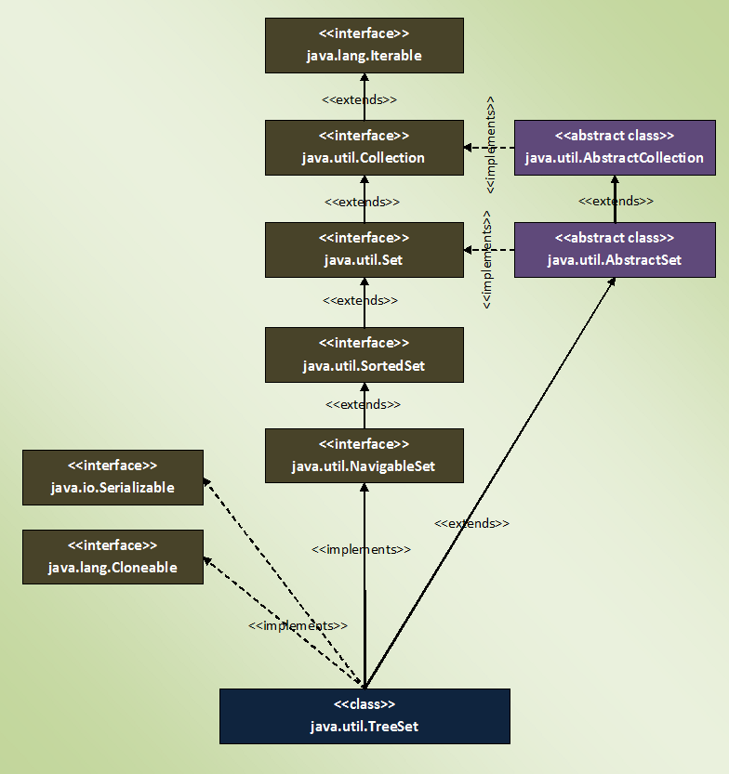

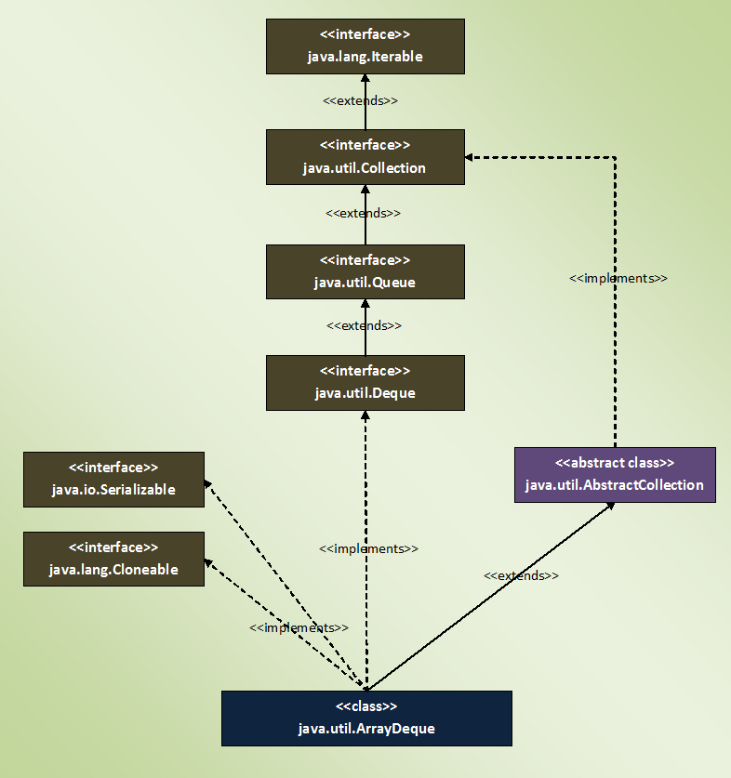

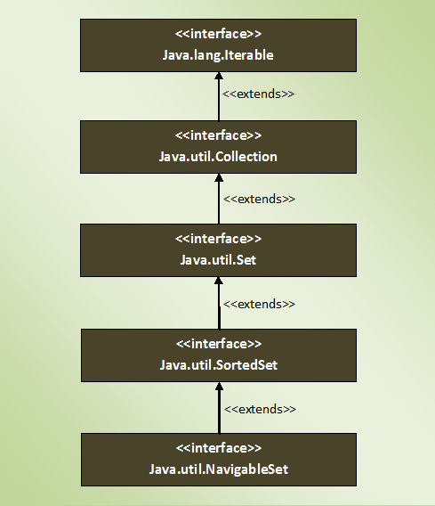

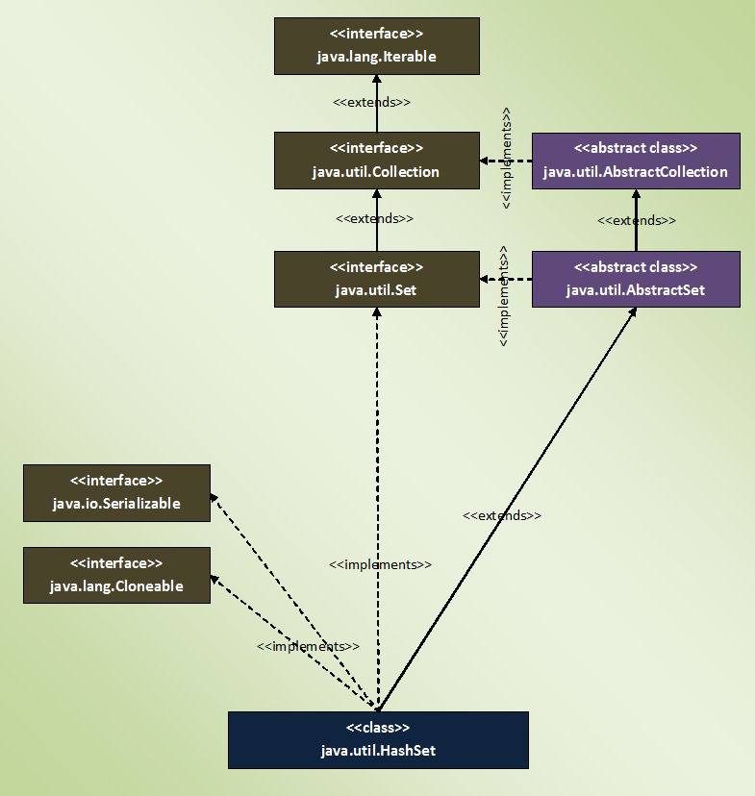

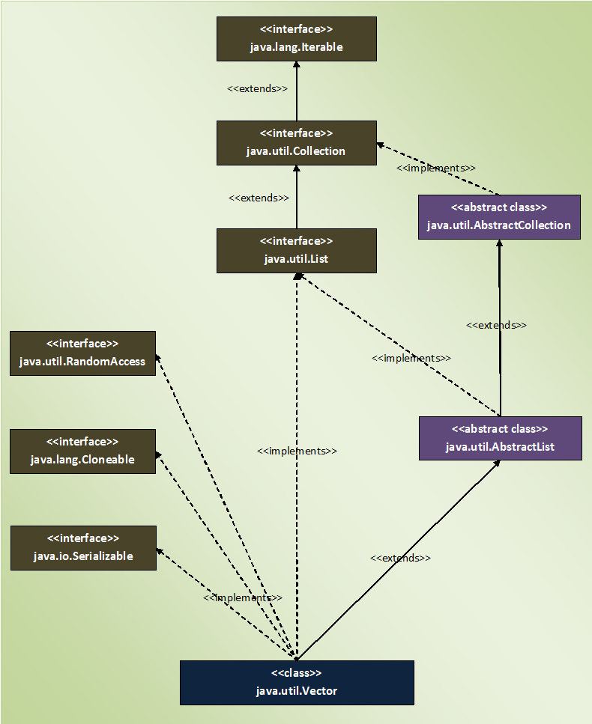

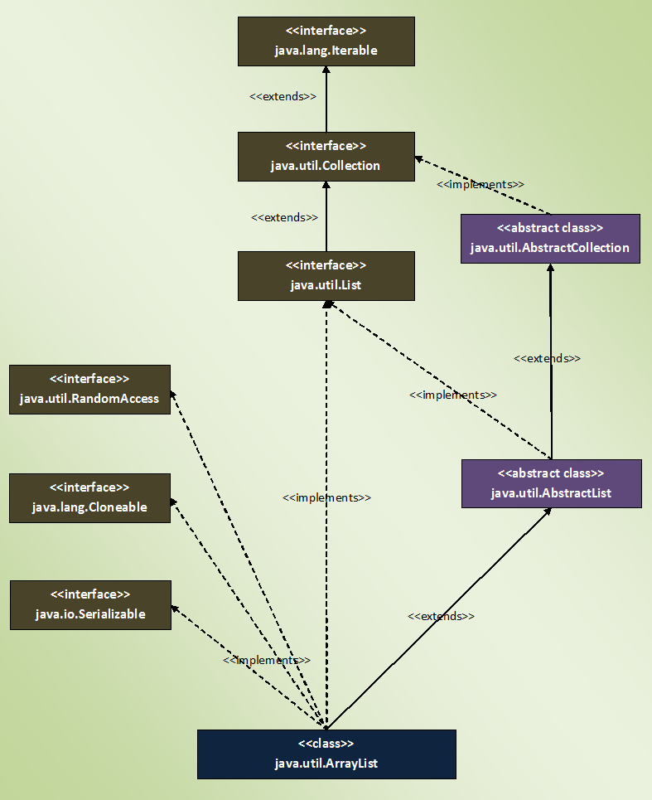

Limitations of arrays:

1. Fixed in size
2. Homogenous
3. No underlying Data structure: no readymade methods support

To overcome these limitations, we go for collections.

Collections:

1. Growable in nature
2. Can hold both homogenous and heterogenous elements
3. Every class is implemented on some standard data structure, hence readymade methods are available.

**If we know size in advance it is suggestable to go for Array which improves the performance.**

**In collections we can hold objects not primitives.**

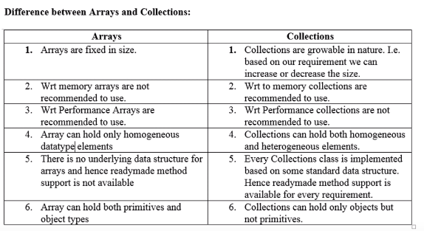

**Collection:** Is a group of individual objects that represent as a single entity.

**Collection Framework:** It defines several classes and interfaces that can be used to represent collection.

**9 Key Interfaces of Collection Framework:**

1. **Collection:** It has the most common methods which are applicable by any collection object.

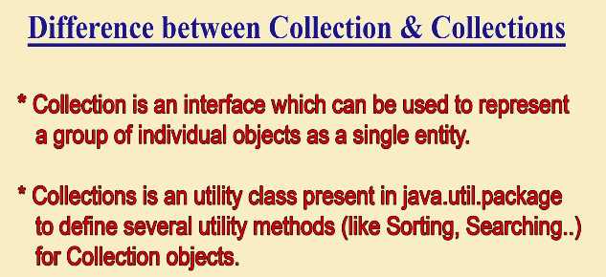

1. **List:**  used when duplicates are allowed, and insertions order preserved.

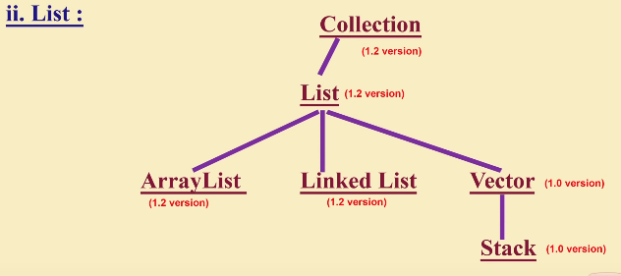

1. **Set:** used when duplicates are not allowed, and insertion order is not preserved.
2. **SortedSet:** where duplicates are not allowed, but objects should be inserted according to some sorted order.
3. **NavigaleSet:** It defines several methods for navigation purposes.
4. **Queue:** If we want to represent a group of individual objects prior to processing.
5. **Map:**  not child interface of collection. If we want to represent a group of individual objects as key value pairs. No duplicate keys are allowed.

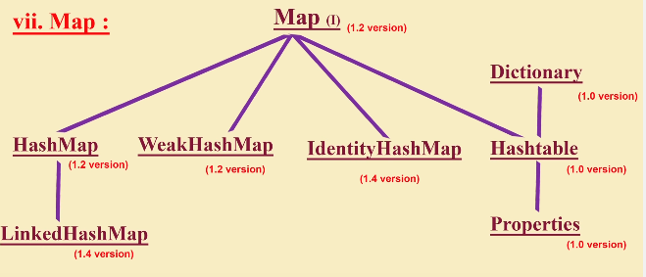

1. **SortedMap:** When we want to represent a group of key value pairs according to some sorting order of keys.
2. **NavigableMap:** defines several methods for navigation purposes.

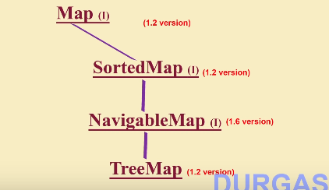

**For Sorting**:

Comparable(I): default nature of sorting order.

Comparator(I): customized sorting.

**Cursors**: For getting objects of collections

1. Enumeration(I)
2. Iterator(I)
3. ListIterator(I)

**Utility classes**: Collections and Arrays.

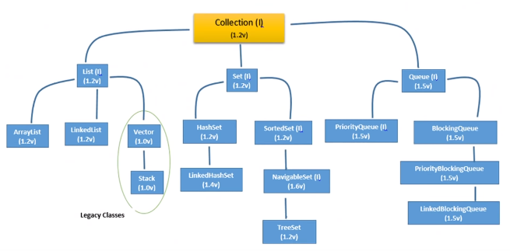

**Methods of Collection Interface:**

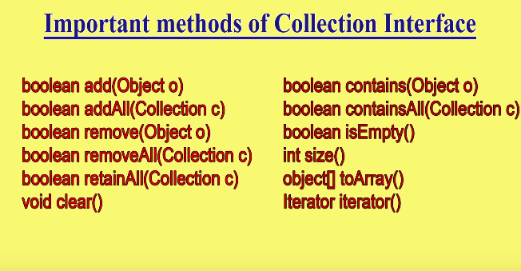

Collection Interface doesn’t contain any method to retrieve objects.

**Methods of List Interface:(all methods deals with index)**

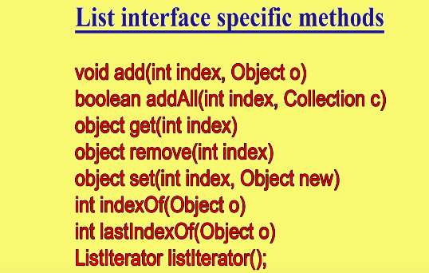

**ArrayList:**

1. Underlying Ds for Arraylist is **Growable array or Resizable Array.**
2. Duplicates allowed.
3. Insertion order preserved.
4. Heterogenous Objects allowed. (**Except Treeset and TreeMap not allowed**)
5. Null insertion possible.

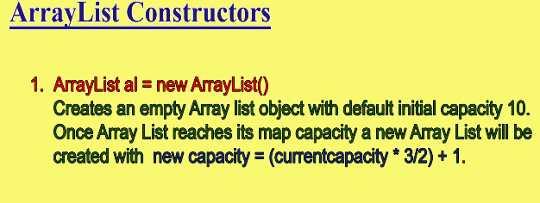

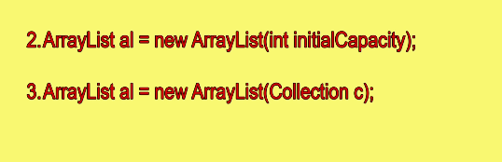

**Note: Every collection object implements Serializable (**to hold and transfer objects from one place to another**) and Cloneable Interface (**to make duplicate copy**) by default.**

**Note: only Arraylist and Vector implements RandomAccess(I) (Marker Interface present in Util package). By this these can retrieve any random element in the list at same speed.**

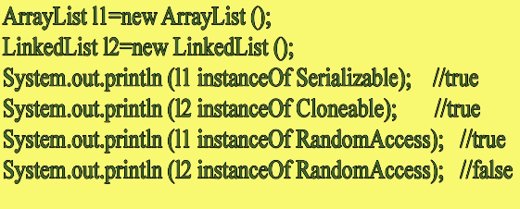

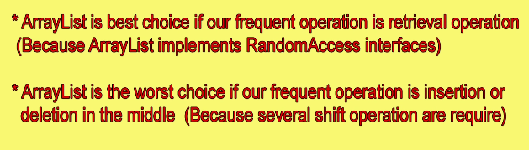

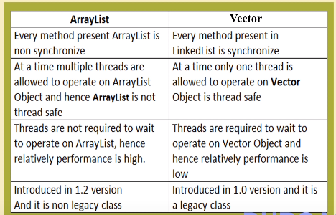

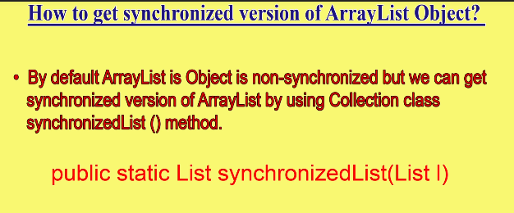

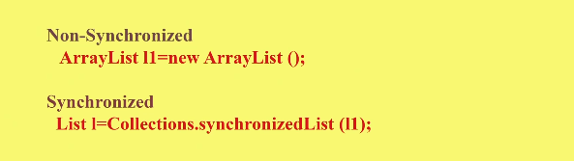

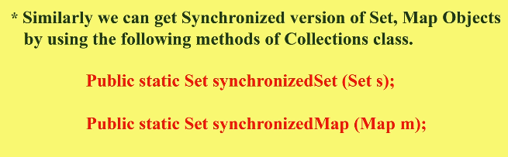

**Linked List:**

* If your requirement is insertion of elements or removal of elements from middle, then linkedlist is the best choice because there is no need of shift operations.
* For every search operation and retrieval of elements then linked list is the worst choice. Which reduces the performance.

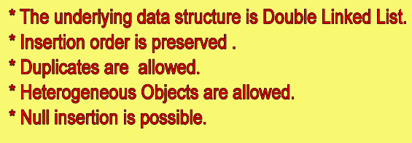

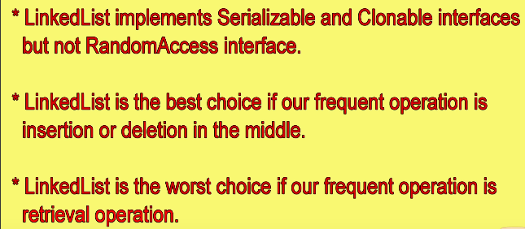

* Usually linked list implements stacks and queues here linked list implements Deque to get some specific methods.

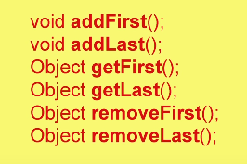

**Constructors:**

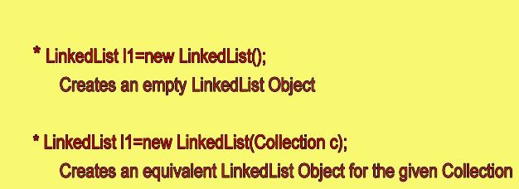

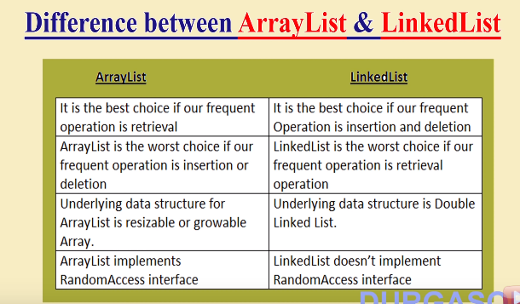

**Vector:**

* Underlying data structure is resizable array or growable array.
* Duplicates are allowed
* Insertion order is preserved.
* Null is allowed
* Heterogenous objects are allowed
* Implements all three serializable, cloneable, and RandomAccess.
* **Synchronized (thread safe).**

**Vector Specific methods:**

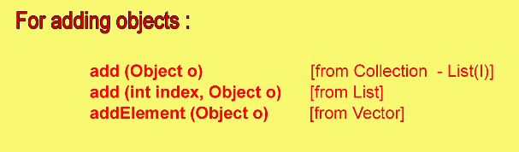

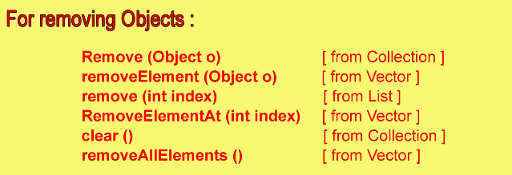

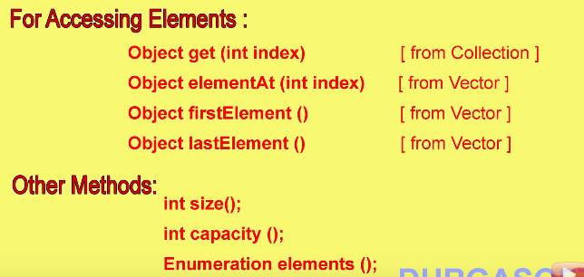

**Constructors:**

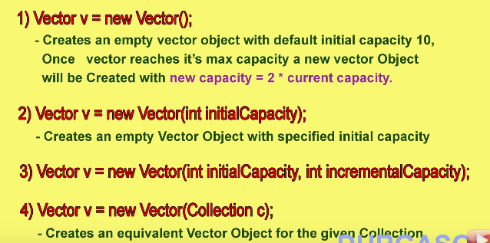

**Stack:**

* Child class of vector specially designed for LIFO.

**Constructor:**

* **Stack s = new Stack();**

**Methods specific to stack:**

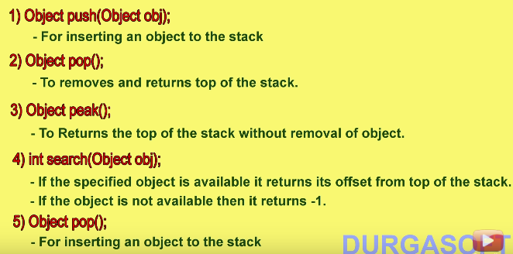

**Cursors in Java for Collections:** to retrieve objects one by one from collections.

1. **Enumeration:**

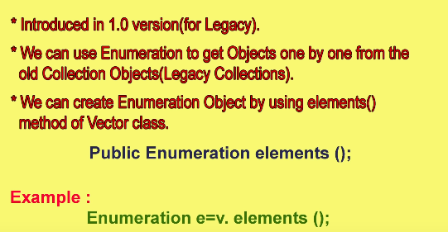

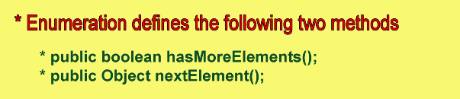

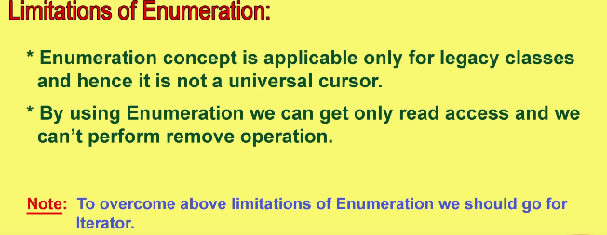

1. **Iterator:**
   * Universal cursor
   * Can perform **both read and remove operation.**
   * We can create iterator object by using the method iterator() of collection interface.

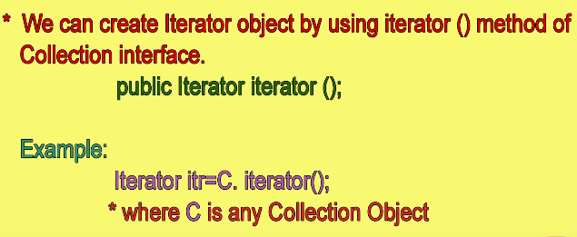

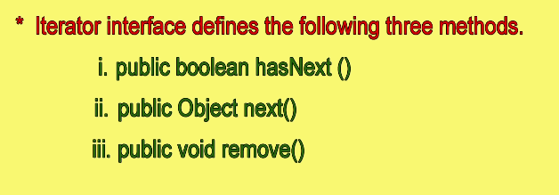

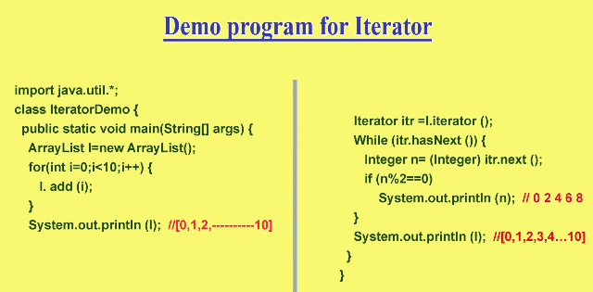

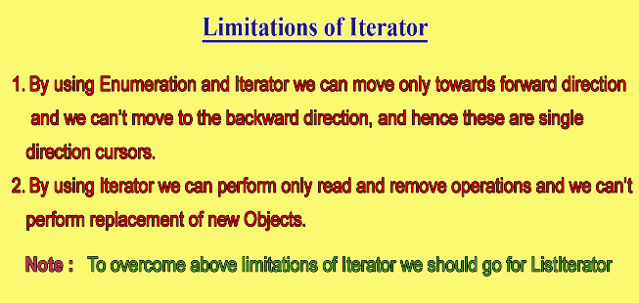

1. **ListIterator:**

* Bi-directional cursor.
* We can perform **read, remove, replacement and addition of new objects**.
* ListIterator implements Iterator.

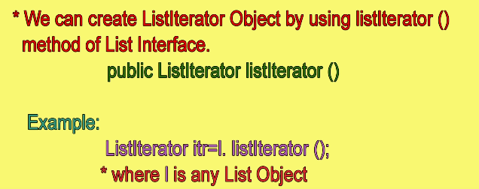

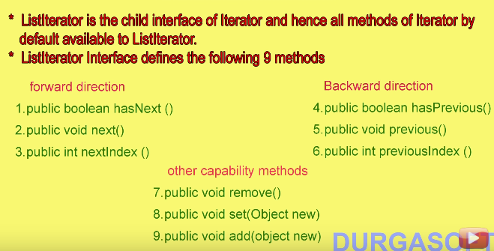

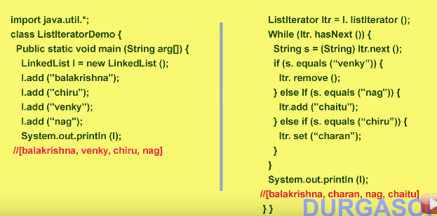

**The problem with ListIterator is it is applicable only to list implemented classes.**

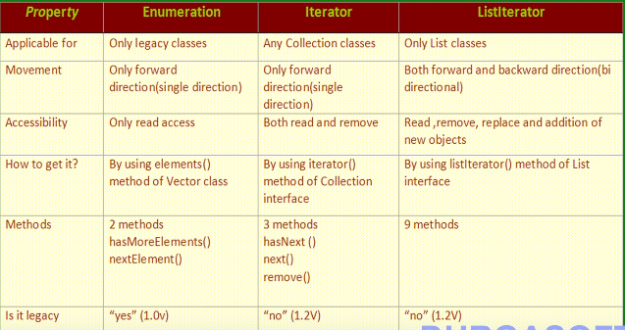

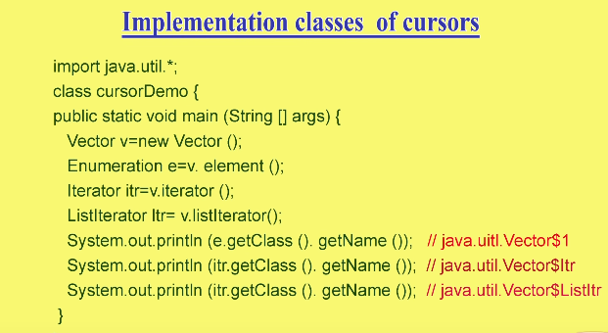

* Implementation class for Iterator interfaces is the inner classes inside the methods.

**Set(I):**

* Doesn’t define any new methods.

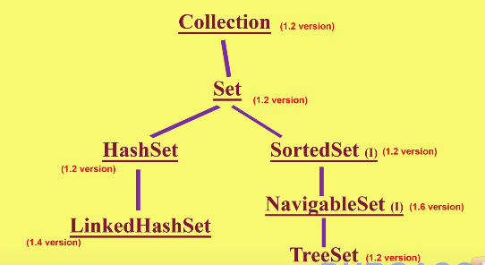

**HashSet:**

* Underlying DS is Hashtable.
* Insertion order is based on hash code of objects not preserved.
* Implements serializable and cloneable interfaces.
* Searching will be easy because of hashing.
* **If our frequent operation is search, then HashSet is best choice**.

**Constructors:**

* **HashSet h = new HashSet();**
  + Initial capacity is 16 and Fill ratio is 0.75.
  + **Fill ratio or Load factor** says when the hashset object has to get the new memory. Here h gets new memory when set is filled 75%.

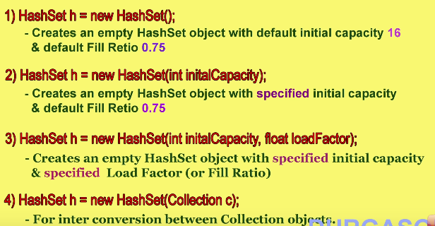

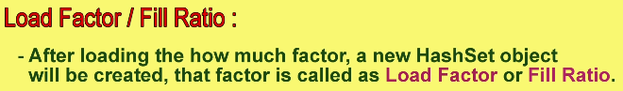

**Linked HashSet:**

* Child class of Hashset.
* Main difference between hashset and Linked hashset is insertion order is preserved.
* Underlying data structure is Hashtable + Linked list.

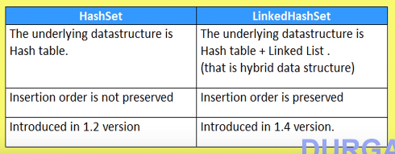

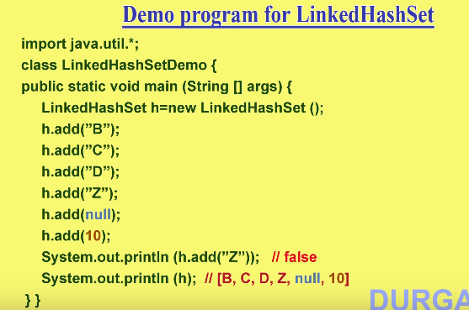

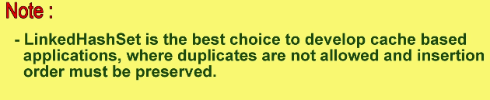

**SortedSet:**

* When we need represent group of objects according to some sorting order with no duplicates.

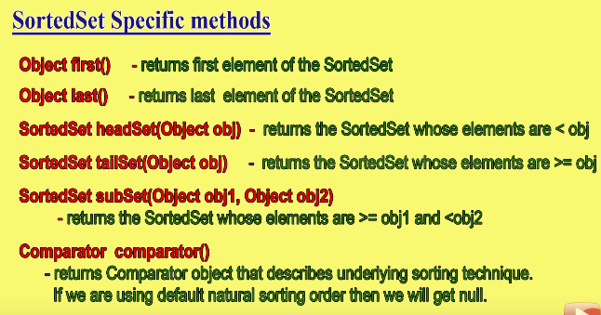

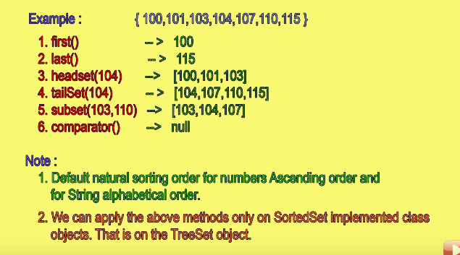

**Treeset:**

* Underlying data structure is Balanced Tree.
* Duplicates are not allowed.
* Insertion order is not preserved but objects are placed according to some sorting order.
* **Heterogenous objects are not allowed. (results in CCE)**
* Null is allowed but only once(as a first element)

**Constructors:**

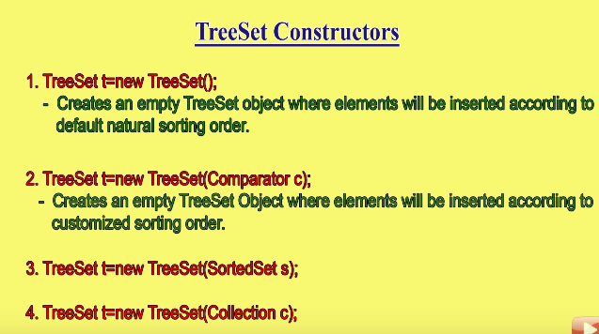

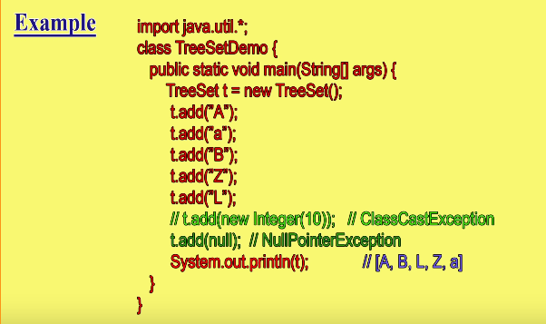

**Null Acceptance:**

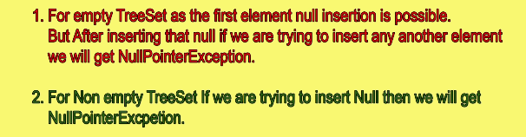

* **If we are depending on default natural sorting order (D.N.S.O) then the objects must be homogenous and comparable.**

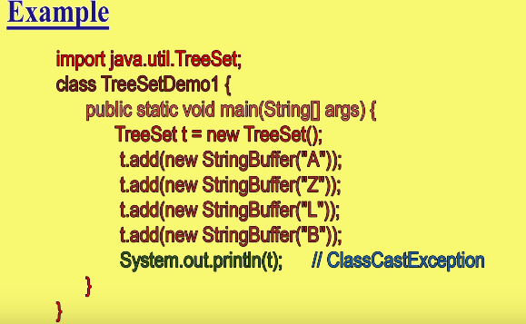

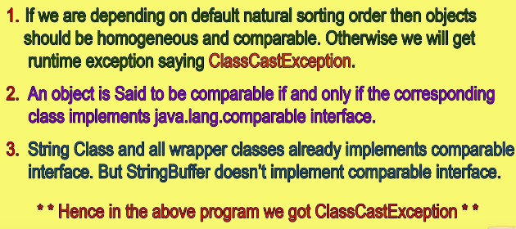

**Comparable(I):**

* Present in java.lang package and contains only one method “compareTo()”

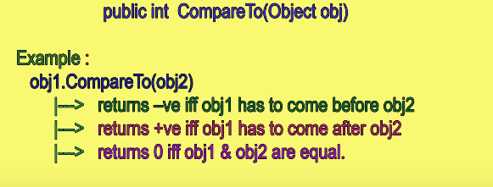

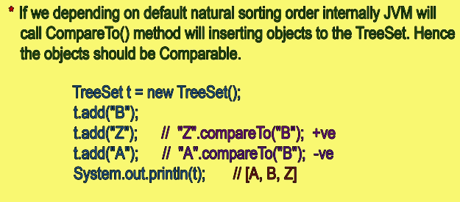

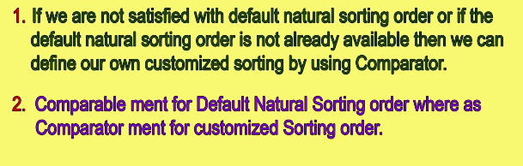

**Comparator(I):**

* Used when need of customized sorting order.
* In Java,Util Package
* Has two methods compare() and equals().

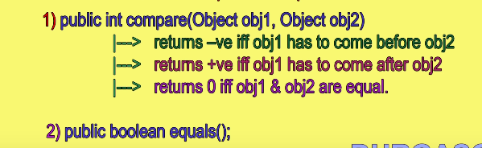

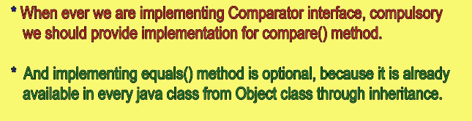

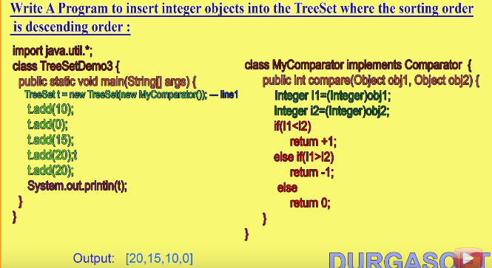

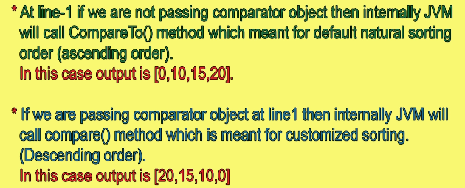

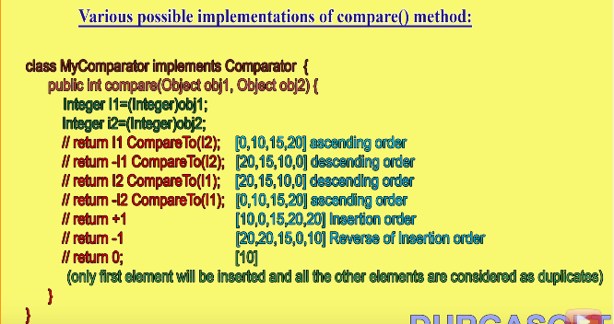

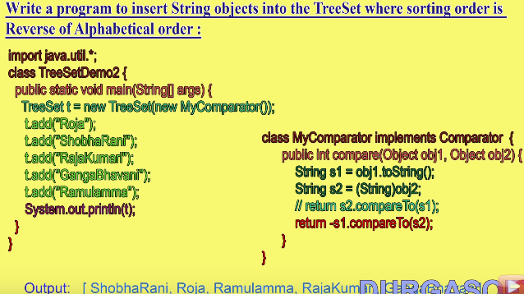

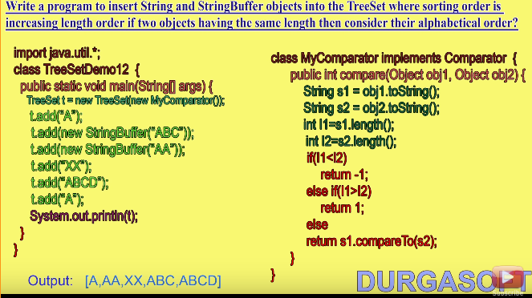

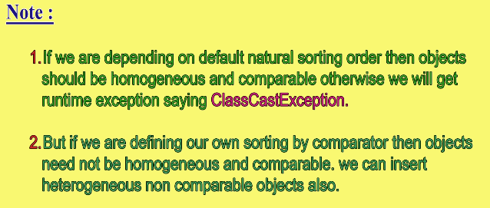

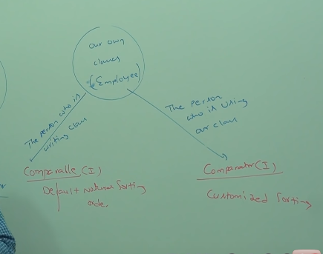

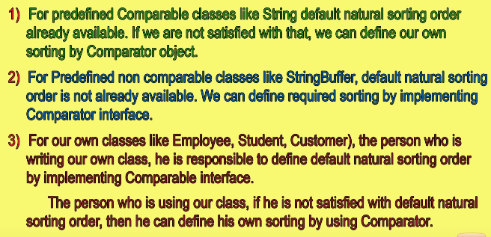

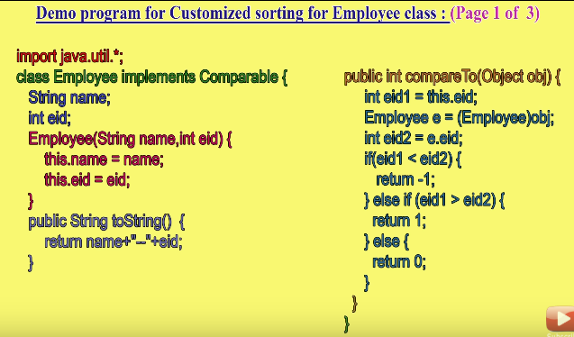

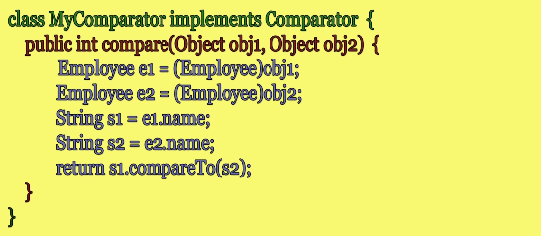

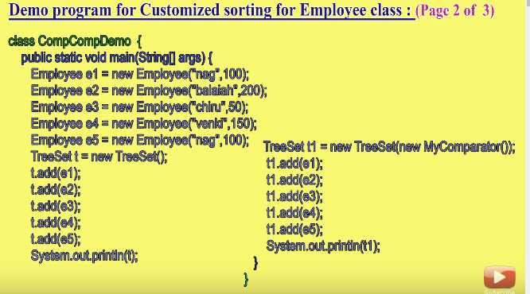

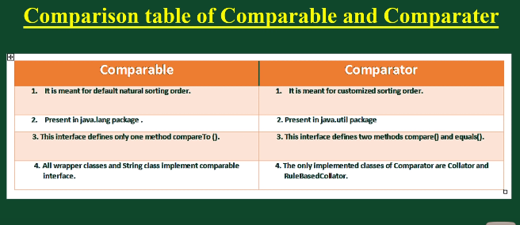

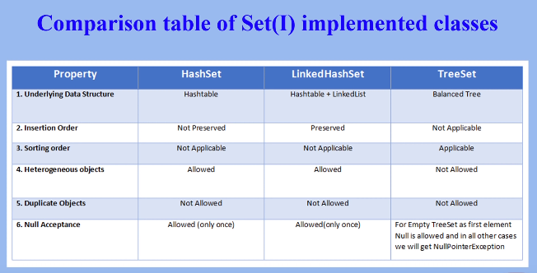

**Map(I):**

* If we want to represent a group of objects as key value pairs.
* Each key value pair is called **Entry**. So map is called a collection of entry objects.

**Methods in Map Interface:**

1. public Object **put(Object key, Object value)**: This method is used to insert an entry in this map.
2. public **void putAll(Map map**): This method is used to insert the specified map in this map.
3. public **Object remove(Object key**): This method is used to delete an entry for the specified key.
4. public **Object get(Object key)**:This method is used to return the value for the specified key.
5. public **boolean containsKey(Object key):** This method is used to search the specified key from this map.
6. public **boolean containsValue(Object Value):** This method is used to search the specified Value from this map.
7. **booelan isEmpty()**
8. public **Set keySet():** This method is used to return the Set view containing all the keys.
9. public **Set entrySet():** This method is used to return the Set view containing all the keys and values.
10. **Collection values()**
11. **int size()**
12. **void Clear()**

**Entry(I):**

* It is the inner Interface of the map Interface.
* It has 3 methods which can be applied on entry.

**Entry Specific Methods:**

* Object getKey()
* Object getValue()
* Object SetValue(Object newvalue)

**HashMap:**

* Underlying Ds is Hash table.
* Insertion order is not preserved, based on hashcode of keys.
* Duplicate keys are not allowed, but Duplicate values are allowed
* It allows Heterogenous objects for both key and value.
* Null is allowed for key only once
* Null is allowed for values any number of times.
* It implements Serializable and cloneable Interfaces.
* It is the best choice if our frequent operation is search operation.

**Constructors:**

**Same as Hashset constructors**

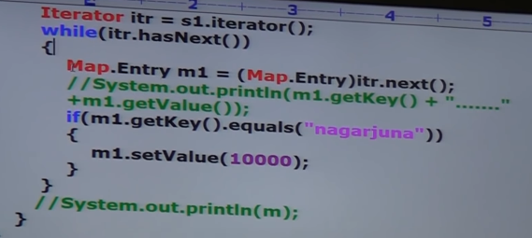

**HashMap and Hashtable:**

|  |  |
| --- | --- |
| **HashMap** | **Hashtable** |
| 1. Every method present in hash map is not synchronized | 1. Every method present in hash table is synchronized |
| 1. not thread safe | 1. Thread safe |
| 1. High performance | Low performance |
| 1. Null is allowed for both key and values | Null is not allowed |

**Synchronized version of Map:**

Map m1= Collections.synchronizedmap(m);

**Linked HashMap:**

* Child class of HashMap
* Underlying DS is Linked list + Hashtable
* Insertion order is preserved.
* Generally used for developing Cache based applications.

**Identity HashMap:**

* Generally Hashmap uses equals method to find duplicate keys.
* Same as HashMap except in identity Hashmap it uses == operator to find the duplicate keys (means compares the reference)

**Weak HashMap:**

* It is exactly same as hashmap except the following difference
  + In case of hashmap even though object doesn’t have any reference, it is not eligible for GC if it is associated with hashmap. (HashMap dominates GC)
  + But in case of WeakHashMap if object doesn’t contain any references it is eligible for GC event though object is associated with WeakHashMap (GC dominates WeakHashMap)

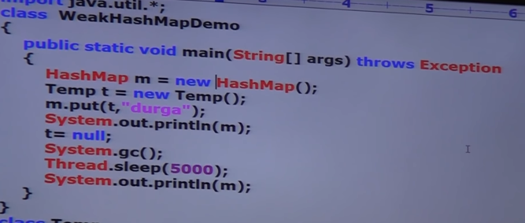

**SortedMap(I):**

* If we want add entries according some sorting order of keys.
* Methods are similar to sorted set.

**TreeMap:**

* Underlying DS is **Red-Black Tree**.
* Insertion order is not preserved, because it is based on hashcode.
* Duplicate keys are not allowed
* If we are depending on DNSO then keys should be homogenous and comparable otherwise we get CCE.
* If we are defining our own comparator by sorting keys need not be homogenous and comparable.
* Values has no restrictions.
* Constructors:
  + Same constructors as Treeset.

**Hashtable:**

* Null key and Null value are not allowed.
* We can override the hashcode method of a class to change the order of insertion.

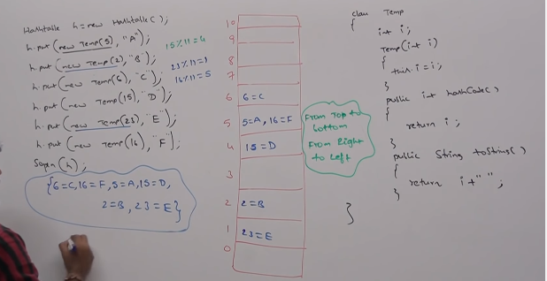

**Properties:**

* Both key and values should be strings.
* Methods:
  + String setProperty(String pname, String pvalue)
  + String getProperty(String pname)
  + Enumeration propertyNames()
  + To load and store properties between file.
    - Void load(InputStream is)
    - Void store(OutputStream os, String comment)

**Queue:**

* If we want to store something prior to processing.
* **FIFO**
* Child interface of collection

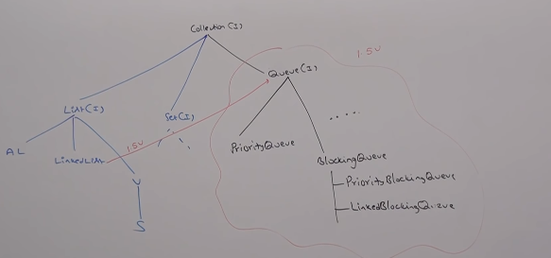

* Usually queue follows FIFO based on our requirement we can implement our own priority order also.
* Linkedlist based implementation of queue follows FIFO
* **Methods Specific to queue.**
  + Offer(Object 0) // add element queue
  + Poll() // remove head element of queue
  + Remove() // same as poll but when queue is empty then it gives NoSuchElementException
  + Peek() // gives head element
  + element() // same as peek but gives Exception when queue is empty.

**Priority Queue:**

* to process some group of elements prior to processing according to some priority.
* Priority can be DNSO or CSO
* Duplicates are not allowed.
* If we are depending on DNSO then objects should be Homogenous.
* Null is not allowed.

**Constructors:**

